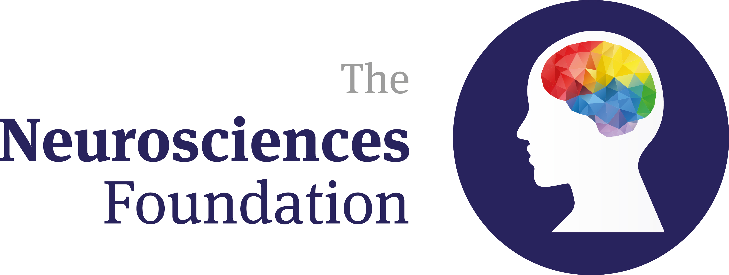
Studentship application form
Notes:
Please rename the file ‘NSF Student Application and surname of the PI: e.g. ‘NSF Student Application, Smith’.

The entitlement is £37,500 over three years. This has to be matched by funds from another source or sources.

A representative of the Neurosciences Foundation should be involved in student selection.

1. Project title and names of applicants [up to 4 applicants]:

2. Summaries

Project summary (maximum 300 words ):

Lay summary (maximum 500 words):

3. Principal applicant’s details:

Title and full name (Principal applicant)
Full address

Telephone no./ext. | E-mail |  |  | Hours per week
Organisation |  | Department | Position

4. Co-applicants’ details: [copy and paste as required up to a maximum of 3 co-applicants]

Title and full name (Principal applicant)
Full address

Telephone no./ext. | E-mail |  |  | Hours per week
Organisation |  | Department | Position

5. Contact for organisation offer to provide matched funding (a formal letter will be required before release of funds):

Title and full name
Full address

Telephone no./ext.

Organisation |  | Department | Position

6. Proposed research theme to be addressed by the studentship:

- Title

- Introduction (citing key references, searches used, etc.)

- Pilot data

- Research questions

- Primary and secondary endpoints

- Study design

- Future exploitation plan, including potential funding sources

- Key references

8. Report on previous NSF grant(s)
For each NSF grant that you or any of your co-applicants have held as principal applicant and which terminated over the past seven years, please give the information requested below:

Project title:

Start date: | Finish date:
Chief Investigator/co-Investigators:

Scientific papers directly resulting from this grant:

Significance: further projects, grants, publications arising from this grant

9. Please attach a one-page CV for each applicant.

